Assignment 3

Output

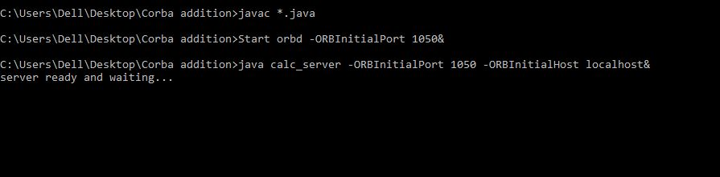
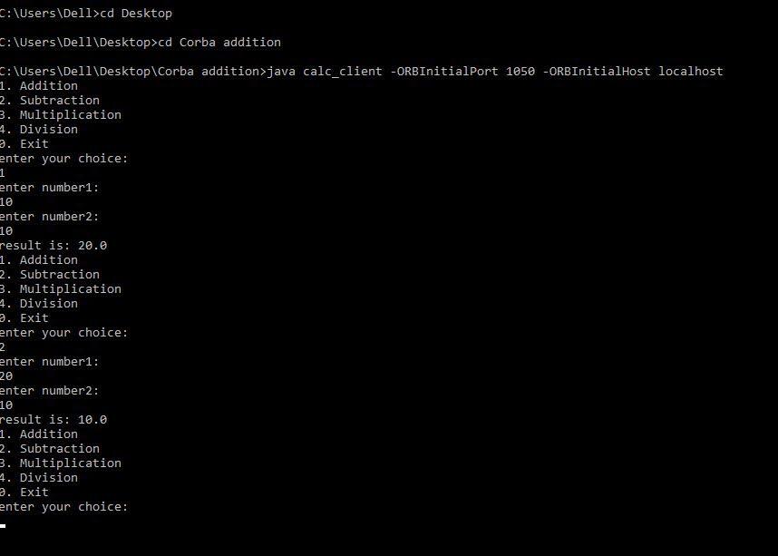

calc.idl

module calc_val
{
interface calc
{
double addfn(in double a,in double b);
double subfn(in double a,in double b);
double mulfn(in double a,in double b);
double divfn(in double a,in double b);
};
};

calc_client.java

import calc_val.*;
import org.omg.CosNaming.*;
import org.omg.CosNaming.NamingContextPackage.*;
import org.omg.CORBA.*;
import java.io.*;
public class calc_client
{
static calc calcimpl;
public static void main(String args[])
{
try
{
double result=0.0,num1=0.0,num2=0.0;

// create and initialize the ORB
ORB orb=ORB.init(args,null);
// get the root naming context
org.omg.CORBA.Object objref=orb.resolve_initial_references("NameService");
// Use NamingContextExt which is part of the Interoperable Naming Service (INS) specification.
NamingContextExt ncref=NamingContextExtHelper.narrow(objref);

String pathname="calc";
calcimpl=calcHelper.narrow(ncref.resolve_str(pathname));

int ch=1;

while(ch!=0)
{
System.out.println("1. Addition");
System.out.println("2. Subtraction");
System.out.println("3. Multiplication");
System.out.println("4. Division");
System.out.println("0. Exit");

BufferedReader in1=new BufferedReader(new InputStreamReader(System.in));

System.out.println("enter your choice: ");
ch=Integer.parseInt(in1.readLine());

if(ch==0)
break;

BufferedReader in=new BufferedReader(new InputStreamReader(System.in));

System.out.println("enter number1: ");
num1=Double.parseDouble(in.readLine());

System.out.println("enter number2: ");
num2=Double.parseDouble(in.readLine());

switch(ch)
{
case 1:
result=calcimpl.addfn(num1,num2);
break;

case 2:
result=calcimpl.subfn(num1,num2);
break;

case 3:
result=calcimpl.mulfn(num1,num2);
break;

case 4:
result=calcimpl.divfn(num1,num2);
break;

}
System.out.println("result is: "+result);

}

}
catch(Exception e)
{
System.out.println(e);
}
}

}

calc_server.java

import calc_val.*;
import org.omg.CosNaming.*;
import org.omg.CosNaming.NamingContextPackage.*;
import org.omg.CORBA.*;
import org.omg.PortableServer.*;
import org.omg.PortableServer.POA;

class serverimpl extends calcPOA
{
private ORB orb;
public void setorb(ORB orb_val)
{
orb=orb_val;
}

public double addfn(double n1,double n2)
{
return(n1+n2);
}
public double subfn(double n1,double n2)
{
return(n1-n2);
}
public double mulfn(double n1,double n2)
{
return(n1*n2);
}
public double divfn(double n1,double n2)
{
return(n1/n2);
}

}
public class calc_server
{
public static void main(String args[])
{
try
{
//Create and initialize the ORB
ORB orb=ORB.init(args,null);

// get reference to rootpoa & activate the POAManager
org.omg.CORBA.Object objref1=orb.resolve_initial_references("RootPOA");
POA rootpoa=POAHelper.narrow(objref1);
rootpoa.the_POAManager().activate();

//create servant and register it with the ORB
serverimpl serverobj=new serverimpl();
serverobj.setorb(orb);

// get object reference from the servant
org.omg.CORBA.Object objref2=rootpoa.servant_to_reference(serverobj);
calc href=calcHelper.narrow(objref2);

// get the root naming context
org.omg.CORBA.Object objref3= orb.resolve_initial_references("NameService");

// Use NamingContextExt which is part of the Interoperable Naming Service (INS) specification.
NamingContextExt ncref=NamingContextExtHelper.narrow(objref3);
String pathname="calc";
NameComponent path[]=ncref.to_name(pathname);

// bind the Object Reference in Naming
ncref.rebind(path,href);

System.out.println("server ready and waiting...");
// wait for invocations from clients
orb.run();

}
catch(Exception e)
{
System.out.println(e);
}
}

}

